SIMATS ENGINEERING (SAVEETHA SCHOOL OF ENGINEERING)
Department of Computer Science and Engineering
CO2 ASSESSMENT TOOL 1 – Scenario-Based Requirement Analysis

Course Code: | CSA10 / CSA1004 | Course Title: | Software Engineering
CO Assessed: | CO2 | Assessment: | Assessment Tool 2 – Scenario-Based Requirement Analysis
Weightage: | 20% | Total Marks: | 25
CO2 Statement: | Perform detailed requirements analysis, design scalable architectures, and prioritize features with a focus on cross-disciplinary skills
Student Name: |  | Reg. No.:
Date: | 27.10.26 | Duration: | 60 minutes

Code of Conduct
I KANDALA CHANDANA (192525363) (Name / Reg No) certify that this submission is my original work and that I have adhered to the guidelines specified for this assessment. I understand that any violation of academic integrity rules will result in disciplinary action.
Signature of the Student: Chandana
Annexure A – Scenario-Based Requirement Analysis
Instructions to Students:
Each student will be assigned an individual software project problem statement. Analyse the given scenario and prepare a complete Software Requirement Analysis document by following the steps below.

Question
Based on the assigned problem statement, perform a Scenario-Based Requirement Analysis and prepare a Software Requirement Specification (SRS) document. Your analysis should include the following:
- Study and Analyse the Scenario
  - Carefully understand the given problem statement.
  - Identify the business domain, stakeholders, existing challenges, and system objectives.
- Identify Functional and Non-Functional Requirements
  - List all functional requirements required by the proposed system.
  - Identify suitable non-functional requirements such as performance, security, reliability, usability, scalability, maintainability, and availability.
- Identify Actors and Use Cases
  - Identify all primary and secondary actors interacting with the system.
  - List the major use cases associated with each actor.
  - Draw a Use Case Diagram representing the interactions between actors and the system.
- Prepare the Software Requirement Specification (SRS)
Develop an SRS document containing:
  - Introduction
  - Problem Description
  - Scope of the System
  - Functional Requirements
  - Non-Functional Requirements
  - Use Case Descriptions
  - Data Requirements
  - External Interface Requirements
  - System Features
- Identify Assumptions and Constraints
  - List the assumptions considered while developing the system.
  - Identify technical, operational, economic, legal, and time-related constraints affecting the project.
- Validate Requirement Completeness and Consistency
  - Verify whether all stakeholder requirements have been addressed.
  - Check for ambiguity, redundancy, inconsistency, and missing requirements.
  - Suggest improvements to enhance the quality and completeness of the requirement specification.

Executive Summary
The Intelligent Tourism Recommendation and Trip Planning System is proposed as a user-friendly platform that helps tourists discover suitable destinations and prepare practical travel plans. It uses information such as travel interests, available budget, trip duration, preferred location and feedback to recommend destinations and create a personalized itinerary. The system also provides attraction information, estimates travel expenses and allows users to save and review trip plans. This report analyses the scenario, stakeholders, functional and non-functional requirements, actors, use cases, data needs, interfaces, assumptions, constraints and requirement validation.

Report Contents
- 1. Scenario Study and Problem Analysis
- 2. Objectives, Scope and Stakeholders
- 3. Functional Requirements
- 4. Non-Functional Requirements
- 5. Actors and Use Case Model
- 6. Software Requirement Specification (SRS)
- 7. Data and External Interface Requirements
- 8. Assumptions and Constraints
- 9. Requirement Validation and Risk Analysis
- 10. Proposed Architecture and Workflow
- 11. Testing and Acceptance Criteria
- 12. Conclusion and References

1. Scenario Study and Problem Analysis

1.1 Problem Description
Tourists often need to compare many destinations, attractions, travel options and estimated expenses before making a trip. Information may be scattered across different websites and applications. Planning manually can take time, and a plan may not fit the traveller’s budget, interests or available days. The proposed system brings these planning activities into one place and generates recommendations based on the traveller’s stated preferences.

1.2 Business Domain
The system belongs to the tourism and travel-planning domain. It supports destination discovery, personalized recommendation, itinerary preparation, budget estimation and feedback collection. It is intended as a planning assistant; unless connected to verified third-party services, it does not guarantee live prices, bookings or real-time availability.

1.3 Existing Challenges
- Travel information is spread across multiple sources and may be difficult to compare.
- Generic recommendations may not match a tourist’s interests or spending limit.
- Manual day-by-day scheduling can cause inefficient routes or unrealistic timings.
- Travellers may underestimate transport, accommodation, food and attraction expenses.
- Past preferences and feedback may not be retained in a single planning workspace.

1.4 Proposed Solution
The platform collects a tourist profile and trip preferences, recommends destinations, presents attraction details, prepares a day-wise itinerary, estimates costs and stores saved plans. Feedback can be used to improve future recommendations. The design is modular so that mapping, weather, transport or booking integrations can be added later.

2. Objectives, Scope and Stakeholders

2.1 Objectives
- Create and maintain tourist profiles.
- Collect budget, duration, location and interest preferences.
- Recommend destinations that align with the entered preferences.
- Generate a day-wise itinerary for the selected trip.
- Display useful information about tourist attractions.
- Estimate expected travel costs and show a cost breakdown.
- Allow users to save, view and update trip schedules.
- Collect user feedback for quality improvement.

2.2 Scope
Included in the proposed system | Outside the initial scope / future enhancement
Profile and preference management | Direct ticket or hotel booking
Destination and attraction discovery | Guaranteed live price availability
Personalized recommendations | Integrated payment processing
Itinerary generation and trip-cost estimate | Emergency assistance service
Saved trips and feedback | Guaranteed real-time traffic or weather unless integrated

2.3 Stakeholders
Stakeholder | Role / Interest
Tourist / End User | Provides preferences, explores destinations, creates and saves trips, submits feedback.
System Administrator | Maintains destination records, monitors system content and manages reported issues.
Content / Tourism Data Manager | Updates attraction descriptions, categories and estimated costs.
Development Team | Designs, implements, tests and maintains the system.
External Service Provider (optional) | May provide maps, geolocation, weather or travel information through an API.

2.4 Success Criteria
- A user can enter trip preferences and receive a relevant destination shortlist.
- The system can produce a readable day-wise itinerary for the selected duration.
- A cost estimate displays major expense categories and a total estimate.
- Users can save and reopen their plans without losing stored information.
- Invalid inputs are handled clearly and private account data is protected.

3. Functional Requirements
Functional requirements describe the actions the system must perform. Each requirement has a unique identifier to support implementation and testing.
ID | Feature | Requirement statement
FR-01 | User profile | The system shall allow a tourist to register, log in and manage basic profile details.
FR-02 | Preference capture | The system shall collect destination/region, budget, trip duration, interests and travel preferences.
FR-03 | Destination catalogue | The system shall display destination and attraction names, descriptions, categories and estimated visit details.
FR-04 | Recommendation | The system shall rank or filter destinations using the user’s stated preferences.
FR-05 | Itinerary generation | The system shall create a day-wise plan containing selected places and suggested visit order.
FR-06 | Cost estimation | The system shall estimate major expense categories and calculate an overall trip estimate.
FR-07 | Schedule editing | The system shall allow users to add, remove or reorder itinerary items.
FR-08 | Save and retrieve | The system shall allow logged-in users to save and retrieve trip plans.
FR-09 | Feedback | The system shall collect ratings or comments about destinations and recommendations.
FR-10 | Administration | The system shall allow an authorized administrator to add, update or deactivate destination records.
FR-11 | Input validation | The system shall validate required fields, numeric budget values and valid trip duration.
FR-12 | Error messages | The system shall display understandable messages when data is missing or a service fails.

4. Non-Functional Requirements

ID / Quality | Requirement
NFR-01 Performance | For normal usage, common pages and saved trip views should respond within an acceptable target of about 3 seconds under the expected load.
NFR-02 Security | Passwords must be securely hashed; protected pages must require authentication and authorization.
NFR-03 Privacy | Only necessary personal information should be collected and access to user trip history should be restricted.
NFR-04 Usability | Forms, buttons, labels and error messages should be clear for first-time users.
NFR-05 Reliability | The system should validate inputs, handle errors gracefully and avoid saving incomplete or corrupted trip records.
NFR-06 Availability | The deployed application should be available during intended usage hours, subject to hosting and network conditions.
NFR-07 Scalability | The application should support growth in users, destinations and saved itineraries through modular components and suitable database indexing.
NFR-08 Maintainability | Code, data models and interfaces should be modular, documented and testable.
NFR-09 Compatibility | The interface should work on modern desktop and mobile browsers.
NFR-10 Accessibility | Use readable contrast, meaningful labels, keyboard-friendly controls and responsive layouts.

5. Actors and Use Case Model

5.1 Actors
Actor | Type | Responsibilities
Tourist | Primary | Register/login, set preferences, explore destinations, generate itinerary, estimate cost, save trips and submit feedback.
Administrator | Secondary | Manage destination information and oversee system content.
External map / place API | Supporting (optional) | Provides location or attraction data if the project integrates such a service.

5.2 Use Case Diagram
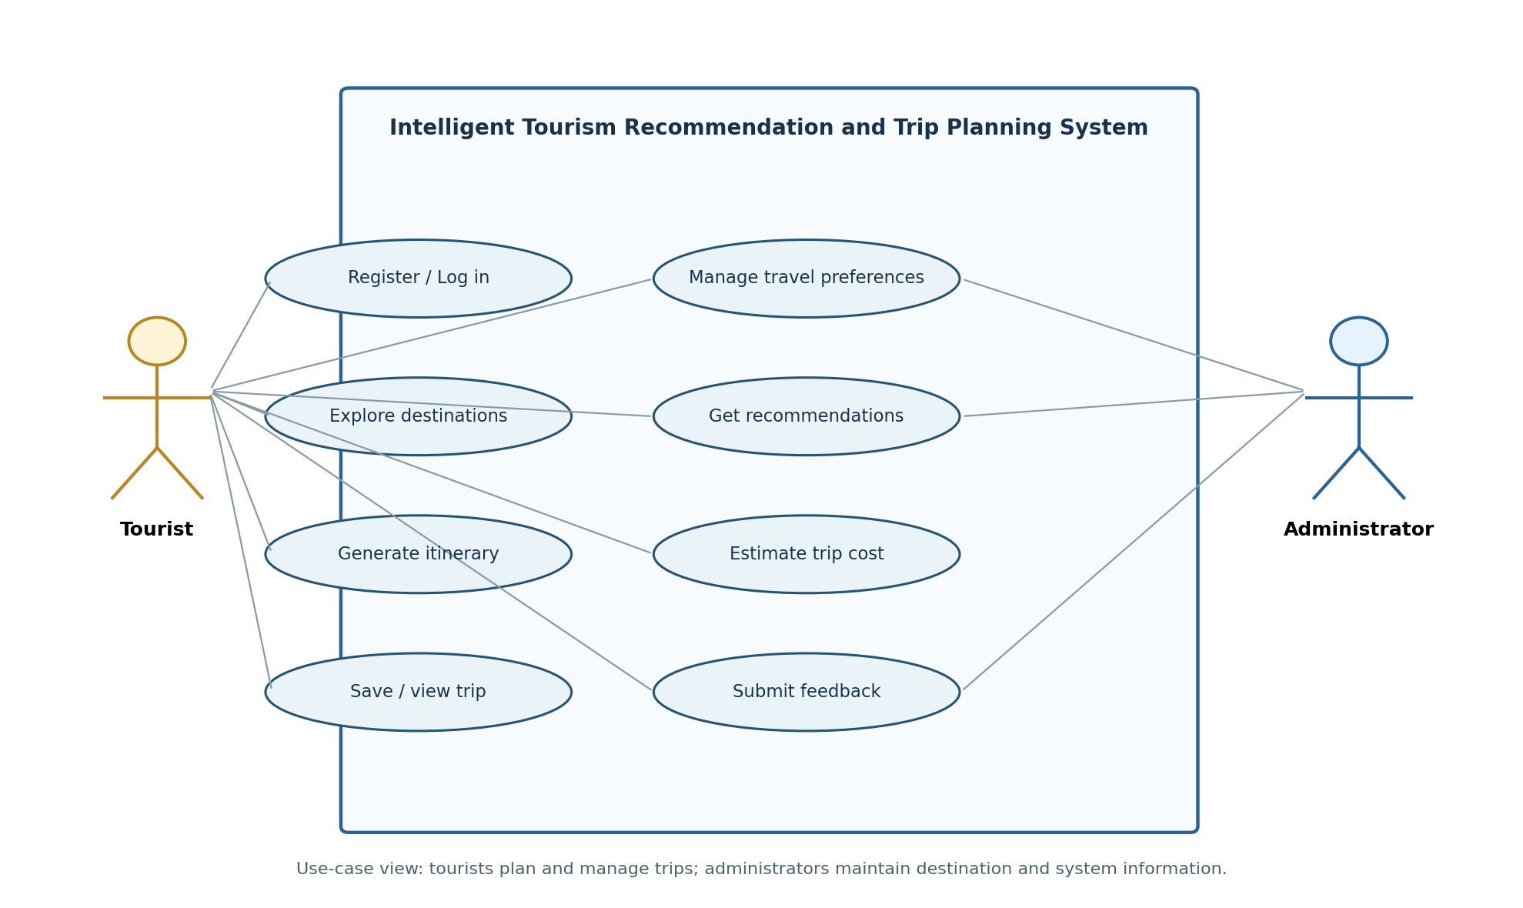
Figure 1. UML-style use case view of the proposed tourism planning system.

5.3 Main Use Case Descriptions
Use Case / Actor | Main Flow | Expected Outcome
UC-01: Manage Profile — Tourist | User opens profile, enters required details and saves changes. | Profile is created or updated after validation.
UC-02: Set Preferences — Tourist | User selects interests, budget, location and trip duration. | Validated preferences are stored for recommendation.
UC-03: Get Recommendations — Tourist | User submits preferences and requests destination suggestions. | System presents matching destinations with short explanations.
UC-04: Generate Itinerary — Tourist | User chooses a destination and requests a plan for the selected number of days. | System creates a day-wise plan that can be reviewed and edited.
UC-05: Estimate Cost — Tourist | User reviews the itinerary and requests an expense estimate. | System displays category estimates and a total, with assumptions stated.
UC-06: Save Trip — Tourist | Logged-in user saves the plan and later opens saved trips. | Trip is associated with the user account and can be retrieved.
UC-07: Manage Destinations — Administrator | Authorized administrator creates or edits attraction information. | Updated records become available to the application.
UC-08: Submit Feedback — Tourist | User submits a rating or comment after reviewing a recommendation or trip. | Feedback is stored and can be reviewed by the system team.

6. Software Requirement Specification (SRS)

6.1 Introduction
This Software Requirement Specification defines the expected behaviour and quality attributes of the Intelligent Tourism Recommendation and Trip Planning System. It provides a common reference for the student developer, evaluator and potential users. Requirements are expressed in testable language wherever practical.

6.2 Product Perspective
The application is a standalone web-based planning system with a user interface, application logic, recommendation and itinerary components, and a persistent data store. Optional third-party APIs may enrich destination information but are not mandatory for the core prototype.

6.3 Product Functions
- Manage user accounts and trip preferences.
- Search and browse destination/attraction information.
- Filter or rank destination options against preferences.
- Generate and edit itineraries by trip duration.
- Estimate trip expenses and show assumptions.
- Save trip plans and capture feedback.
- Allow authorized content administration.

6.4 User Classes and Characteristics

User class | Expected characteristics
Tourist | Basic digital skills; needs a simple, responsive interface and understandable recommendations.
Administrator | Authorized user familiar with destination records and content maintenance.
Developer / Maintainer | Technical user responsible for application updates, testing, backups and troubleshooting.

6.5 Operating Environment
- Client: modern browser on desktop, tablet or mobile.
- Server: local development server or a suitable web-hosting environment.
- Application: a web framework such as Flask may be used for the prototype.
- Database: SQLite for a small academic prototype; a server database may be adopted for larger deployment.

6.6 Design and Implementation Constraints
- Recommendations depend on the quality and completeness of destination data.
- Cost values are estimates and must be labelled as such unless verified through live services.
- Third-party APIs may require keys, internet access, usage limits and compliance with their terms.
- The implementation must fit the available project schedule, hardware and academic requirements.

7. Data and External Interface Requirements

7.1 Data Requirements
Entity | Example fields
User | user_id, name, email, password_hash, created_at
Preference | preference_id, user_id, budget, duration_days, preferred_region, interests
Destination | destination_id, name, region, description, categories, estimated_visit_time
Attraction | attraction_id, destination_id, name, description, estimated_cost, opening_info (if known)
Trip | trip_id, user_id, destination_id, start_date, duration_days, estimated_total, status
Itinerary Item | item_id, trip_id, day_number, attraction_id, sequence_number, notes
Feedback | feedback_id, user_id, destination_id, rating, comment, submitted_at

Data integrity rules: unique identifiers are required; each saved trip belongs to a valid user; itinerary items must reference valid trips; ratings must fall within the defined scale; and required fields must be validated before saving.

7.2 External Interface Requirements
Interface | Requirement
User interface | Responsive pages for profile, preference form, destination list, itinerary, cost estimate, saved trips and feedback.
Software interface | Application routes or APIs connect the UI to recommendation, planning and database functions.
Database interface | Parameterized queries or an ORM should be used; passwords must not be stored as plain text.
Optional map/place API | Use only if configured; handle missing data, timeouts and API errors gracefully.
Error interface | Display actionable messages without exposing stack traces, secrets or internal database details.

7.3 System Features
Feature | Description
Personalized recommendation | Match destinations to user interests, budget and duration; show concise reasons for suggestions.
Itinerary planner | Organize selected attractions by day and allow simple edits.
Cost estimator | Show estimated transport, accommodation, food, attraction fees, local travel and miscellaneous expenses where data is available.
Trip history | Save, reopen and update previous trip plans.
Feedback collection | Store ratings/comments for future evaluation and improvement.
Admin catalogue | Maintain accurate destination and attraction records.

8. Proposed Architecture and Workflow
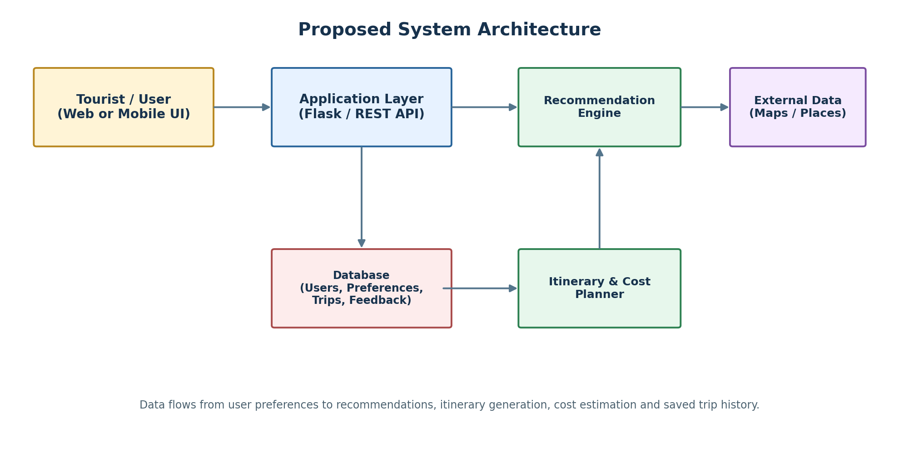
Figure 2. Proposed modular architecture. External services are optional integrations.
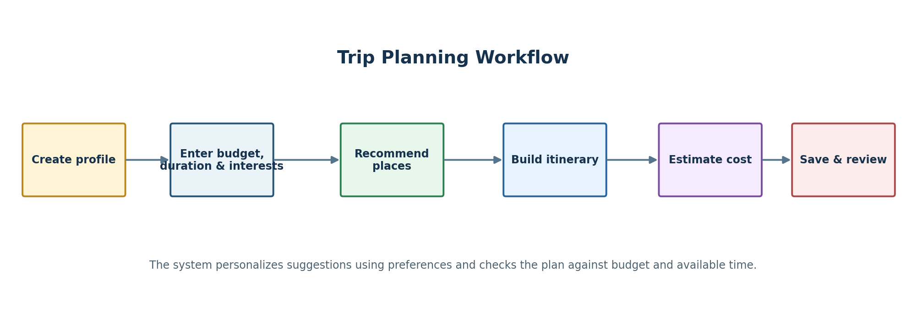
Figure 3. End-to-end trip planning workflow.

8.1 Recommendation Logic (Proposed)
- Collect user interests, region, duration and budget.
- Filter destinations that do not satisfy essential constraints where data is available.
- Score remaining destinations by interest match, estimated affordability and duration suitability.
- Present the best-matching options with brief reasons and any missing-data warnings.
- Allow the tourist to select a destination and generate an editable itinerary.

8.2 Cost Estimation Formula
Estimated Total = Transport + Accommodation + Food + Attraction Fees + Local Travel + Miscellaneous
The estimate should state the number of travellers and days assumed. If one or more expense values are unavailable, the system should clearly label the result as partial rather than presenting false precision.

9. Assumptions and Constraints

9.1 Assumptions
- Users have access to a browser and an internet connection for the hosted version.
- Users provide reasonably accurate preferences, budget and trip duration.
- Destination and attraction records are maintained with reasonable care.
- The prototype uses indicative cost data unless a verified external source is connected.
- Users understand that recommendations support planning and do not guarantee bookings or availability.

9.2 Constraints
Constraint category | Constraint / effect | Mitigation
Technical | Limited API access or incomplete destination data may reduce recommendation quality. | Use a curated sample dataset and make integrations optional.
Operational | Administrators must keep destination records current. | Provide simple data maintenance functions and validation.
Economic | Hosting, map APIs or data services may have usage costs. | Prefer free/student tiers and estimate operating costs.
Legal / privacy | Personal details and third-party data must be handled responsibly. | Collect minimum data, restrict access and follow applicable policies.
Time | Academic submission time limits the scope of implementation. | Prioritize core features; treat live booking and payment as future work.

10. Requirement Validation and Risk Analysis

10.1 Completeness and Consistency Checklist
Validation area | Review result / action
Stakeholder coverage | Tourist, administrator and optional external service provider are considered.
Requirement traceability | Each major feature has a requirement ID and can be mapped to tests.
Ambiguity | Use measurable or observable wording; label estimated data and assumptions.
Redundancy | Profile, preferences, recommendations, itinerary, cost and feedback are separated by purpose.
Consistency | Budget, duration and interests used in recommendations must match the values shown in the user interface.
Feasibility | Core prototype can run without paid APIs using a curated sample dataset.
Security and privacy | Authentication, authorization, password hashing and access restrictions are included.

10.2 Risk Register
Risk | Impact | Mitigation
Outdated attraction data | Recommendations may be misleading. | Show last-updated dates and review catalogue data.
Incorrect cost estimates | User budget planning may be inaccurate. | Display category breakdown, assumptions and estimate disclaimer.
Poor preference matching | Users may receive irrelevant suggestions. | Use clear preference controls and collect feedback.
API unavailable | Map or place details may not load. | Provide fallback catalogue data and graceful error messages.
Unauthorized data access | User privacy may be compromised. | Use secure authentication, authorization and safe database practices.

10.3 Requirement Improvement Suggestions
- Define exact performance targets after expected user load is known.
- Define a measurable recommendation relevance metric for evaluation.
- Specify the currency, cost source and update frequency for all estimates.
- Add accessibility checks and test the UI at mobile and desktop screen sizes.
- Maintain a requirement-to-test traceability matrix throughout implementation.

11. Testing and Acceptance Criteria
Test ID / Area | Test action | Acceptance criterion
TC-01 Profile validation | Submit valid and invalid profile details. | Valid data is accepted; invalid or missing fields show clear errors.
TC-02 Preference capture | Enter budget, interests and duration. | Preferences are validated and stored correctly.
TC-03 Recommendation | Submit different preference combinations. | Results reflect the entered interests and constraints.
TC-04 Itinerary generation | Generate a plan for a selected duration. | Plan is organized by day and can be edited.
TC-05 Cost calculation | Use known sample expense values. | Displayed category totals and grand total are arithmetically correct.
TC-06 Save and retrieve | Save a trip, sign out/in and reopen it. | The correct saved plan is retrieved for the authenticated user.
TC-07 Feedback | Submit valid rating and comment. | Feedback is stored and displayed/available to authorized reviewers.
TC-08 Access control | Attempt to open an admin page as a tourist. | Unauthorized access is denied.
TC-09 Error handling | Simulate missing data or unavailable optional API. | System shows a useful message and remains usable.

11.1 Sample Acceptance Criteria
- A tourist can complete the main planning workflow without assistance.
- A generated itinerary has one or more planned items for the selected days when matching data exists.
- The cost total equals the sum of displayed expense categories.
- Saved trips are accessible only to the associated authenticated user.
- The system clearly communicates when information is estimated, unavailable or incomplete.

12. Conclusion
This scenario-based analysis converts the Intelligent Tourism Recommendation and Trip Planning System problem into structured, testable requirements. It identifies stakeholders, system objectives, functional and non-functional requirements, actors, use cases, data entities, interfaces, assumptions, constraints and validation checks. The proposed architecture separates the user interface, application logic, recommendation engine, itinerary/cost planner and database, allowing the system to be extended in future versions. The most important implementation priorities are accurate preference handling, useful recommendations, editable itineraries, transparent cost estimates, secure user data and clear error handling.
Rubrics for Calculation
Criteria | Excellent (4 Marks) | Good (3 Marks) | Satisfactory (2 Marks) | Needs Improvement (1 Mark)
Scenario Understanding and Problem Analysis (30%) | Demonstrates thorough understanding of the scenario, stakeholders, objectives, and business context with clear analysis. | Demonstrates good understanding with minor omissions. | Basic understanding with limited analysis. | Poor understanding; major aspects missing or incorrect.
Functional and Non-Functional Requirement Identification (25%) | Clearly identifies comprehensive, accurate, and well-classified functional and non-functional requirements. | Identifies most requirements with minor classification errors. | Identifies only basic requirements; several omissions. | Requirements are incomplete, inaccurate, or poorly classified.
Actor Identification and Use Case Modelling (20%) | Correctly identifies all relevant actors and use cases; use case diagram is complete, accurate, and follows UML standards. | Most actors and use cases identified; diagram has minor errors. | Limited actors/use cases identified; diagram partially correct. | Actors/use cases missing or incorrect; diagram absent or inaccurate.
Software Requirement Specification (SRS) Documentation (15%) | SRS is well-structured, complete, professionally organized, and includes all required sections. | SRS is organized with minor missing sections or formatting issues. | SRS includes only essential sections with limited detail. | SRS is incomplete, poorly organized, or lacks essential components.
Assumptions, Constraints, and Requirement Validation (10%) | Clearly identifies realistic assumptions and constraints; validates requirements for completeness, consistency, and ambiguity with appropriate justification. | Identifies most assumptions and constraints; validation is adequate. | Limited assumptions/constraints; validation is superficial. | Assumptions, constraints, and validation are missing or incorrect.

Criteria | Mark
Scenario Understanding and Problem Analysis (30%) | /5
Functional and Non-Functional Requirement Identification (25%) | /5
Actor Identification and Use Case Modelling (20%) | /5
Software Requirement Specification (SRS) Documentation (15%) | /5
Assumptions, Constraints, and Requirement Validation (10%) | /5
TOTAL | /25

